Rice Knowledge Bank
Mark Bell (UC Davis), 2011

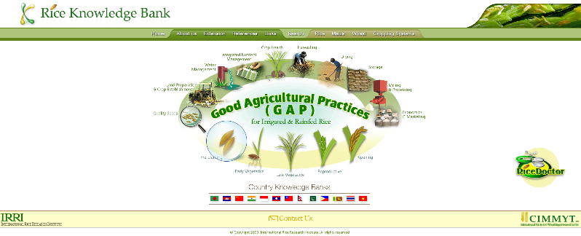

Rice Knowledge Bank – International Rice Research Institute

Factor | Evaluation
Tool (and url) | Rice Knowledge Bank http://www.knowledgebank.irri.org
Tool curator/developer | International Rice Research Institute (IRRI)
Target audience | Development and extension intermediaries working with poor Rice farmers in developing countries
Scale | The RKB is reaching across countries and 13 countries have developed their own banks.
Focus/Content | - Practical field diagnostic tool (Rice Doctor)  - Simple, useful specific answers to specific questions relating to rice production in developing country contexts. (Fact sheets)  - Delivery (extension) and needs assessment methodology
Needs identification process | A network of field users providing feedback on tool structure and content
Source of content | Primarily IRRI scientists using credible research-based and proven information with an “expert” “sign-off” process
Linkage to field application | The RKB was linked and promoted to be used by people working in the field demonstrating technology.
Indicators of success | Web site statistics (2 million+ hits per year) and many anecdotal stories of use.
Evaluations implemented/cost effectiveness | ADB report.
External factors affecting success | Partner countries saw the need.
Sustainability | IRRI is committed to hosting
Why people like it | Provides practical information in an easily accessible form.

Lessons learned (reasons for success?)

Do’s
- Why? Always ask why someone would use my site? Why would they do want I suggest?
- Clarity of focus. Who is the site for? And what information is being provided? The RKB was developed as a tool to deliver technical and training information to intermediaries for use in their work with poor rice farmers. The site did not try and be all things to all people. When it started to enjoy success, people wanted to put all sorts of information on the site. The test was whether the information met a field need in a simple and clear manner – could the information be used – If it was just information, then it was directed to other sites.
- User driven. By being linked to field workers, the site ensured it was demand driven and could respond to emerging needs in terms of site content, site structure and ease of site use and access.
- Project driver. The project had an individual committed to success of the project working with a good team with support of senior management.
- Commitment. IRRI was committed to the long term hosting and maintenance of the site.
- Material form. All materials were available on line and in written form (since not everyone will have internet access). Hard copy quality in black and white was also considered.
- Credible. Before uploading, information was checked and signed off on by experts
- Application. The RKB was linked to and tested by partners active in the field – recognizing that farmers are convinced by what they see – not what they read.
- Promotion. The site became a regular element of training courses – to provide exposure for the site and the opportunity to learn by observing use and listening to feedback.
- Ease of use. Intuitive (and searchable) easy to use interface – tested with user groups
- Bandwidth. The RKB developed materials taking in to account slow connections and small bandwidths. Pictures and diagrams were thus always minimized.
- Change. Sites need an element of change to give the sense of being alive and well – a section on the home site was developed to provide an element that changed regularly, while the bulk of the technical information behind the site remained the same.
- Acknowledge. The site ensured that all contributors were acknowledged. This built in credibility of source and support for the program as people’s contributions were recognized and acknowledge.

Don’ts

- Bells and whistles. Don’t get lost in the technology and the bells and whistles – ensure technology is appropriate to the user conditions.

Summary box. The priority is to provide the information the audience needs in a form they can understand and access.

Elements contributing to successful development.

The website development involved Technical, extension and IT/education experts with linkage to field projects. Each had a clear role.

Roles
- The Technical experts ensured the message was “correct”
- The extension experts ensured the message was “understandable” and packaged in an appropriate and accessible format
- The ICT/education expert ensured materials were being delivered using ICT in a format appropriate for the audience – i.e., the message did not get lost in the delivery tool. ICT was the means (vehicle) not the ends.
- Linkage to the field ensured information was being collated to address “real” problems in a format that was useful, accessible and understandable.

